**SQL Queries**

1) Write a query for the HR department to produce the addresses of all the departments.

Use the LOCATIONS and COUNTRIES tables. Show the location ID, street address,

city, state or province, and country in the output. Run the query



Ans: SELECT location_id,street_address,city,state_province,country_name

-> FROM locations

-> JOIN countries

-> ON locations.country_id=countries.country_id;

2) The HR department needs a report of employees in Toronto. Display the last name, job,

department number, and department name for all employees who work in Toronto.



Ans: SELECT last_name,job_id,employees.department_id,department_name

-> FROM employees

-> JOIN departments

-> ON employees.department_id=departments.department_id

-> JOIN locations ON locations.location_id=departments.location_id

-> WHERE locations.city='Toronto';

3) Create a report for HR that displays the last name and salary of every employee who reports to

King.



Ans: SELECT last_name,salary

-> FROM employees

-> WHERE manager_id = (SELECT employee_id from employees where last_name='King');

4) Create Table MY_EMPLOYEE. Description is shown below:

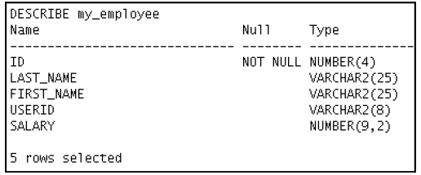

Ans: CREATE TABLE my_employee (

-> ID INT(4) AUTO_INCREMENT PRIMARY KEY,

-> LAST_NAME VARCHAR(25),

-> FIRST_NAME VARCHAR(25),

-> USERID VARCHAR(8),

-> SALARY DECIMAL(9,2));

5) Add the following data to the MY_EMPLOYEE table

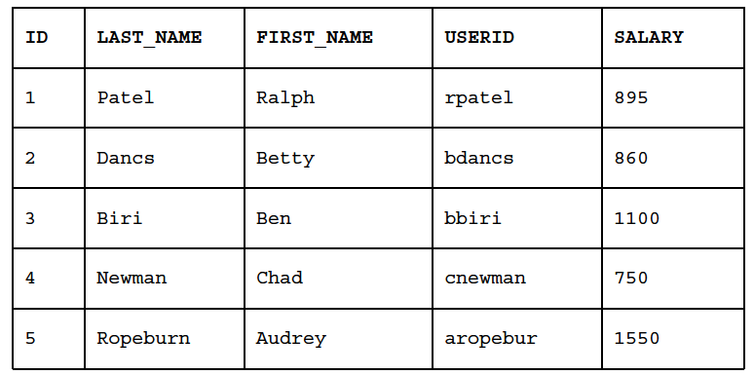

Ans: INSERT INTO my_employee values (1,'patel','Ralph','rpatel',895),

-> (2,'Dancs','Betty','bdancs',860),

-> (3,'Biri','Ben','bbiri',1100),

-> (4,'Newman','Chad','cnewman',750),

-> (5,'Ropeburn','Audery','aropebur',1550);

6) Change the last name of employee 3 to Drexler.

Anss: UPDATE my_employee SET LAST_NAME='Drexler' WHERE ID=3;

7) Change the salary to $1,000 for all employees who have a salary less than $900.

Ans: UPDATE my_employee SET SALARY=1000 WHERE SALARY<900;

8) Delete Betty Dancs from the MY_EMPLOYEE table.

Ans: DELETE from my_employee where last_name='Dancs';

9) Mark an intermediate point in the processing of the transaction.

Ans: start transaction;

savepoint id;

rollback to savepoint id;(Verification)

10) Delete all the rows from the MY_EMPLOYEE table. Confirm that the table is empty.

Ans: DELETE FROM my_employee;

11) Discard the most recent DELETE operation.

Ans:1) START TRANSACTION;

2) DELETE FROM my_employee;

3) SELECT * from my_employee;

Empty set (0.00 sec)

4) ROLLBACK;

5) SELECT * from my_employee; (Verification)

12) Make the data addition permanent.

Ans: INSERT INTO my_employee values (6,'Dummy','Value','dumval',1000);

COMMIT;

13) The staff in the HR department wants to hide some of the data in the EMPLOYEES table. Create

a view called EMPLOYEES_VU based on the employee numbers, employee last names, and

department numbers from the EMPLOYEES table. The heading for the employee name should be

EMPLOYEE.

Confirm that the view works. Display the contents of the EMPLOYEES_VU view

Ans: 1)CREATE VIEW EMPLOYEE_VU AS SELECT employee_id,last_name AS EMPLOYEE,department_id from employees;

2) SELECT * FROM EMPLOYEE_VU;